Target architecture of this course:

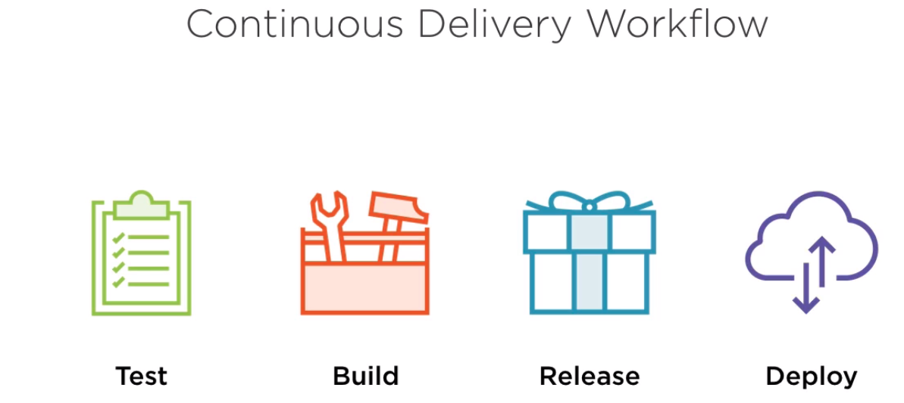

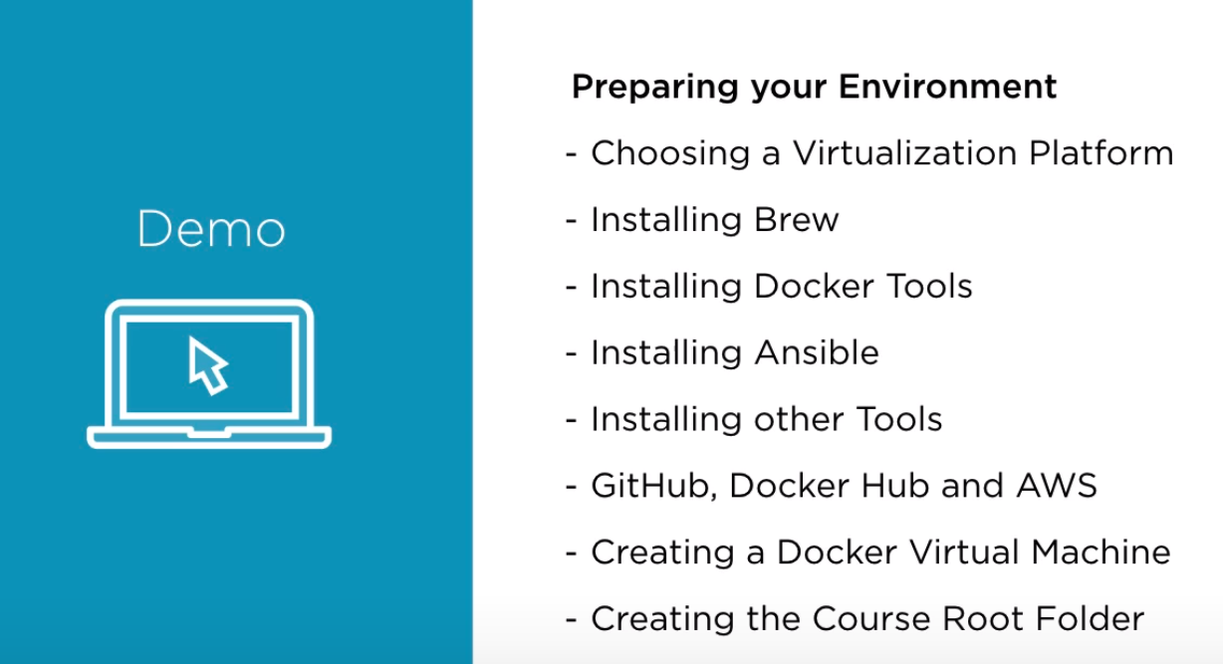

Step1:

Installing docker-compose using below command:

sudo apt install docker-compose

Step2: